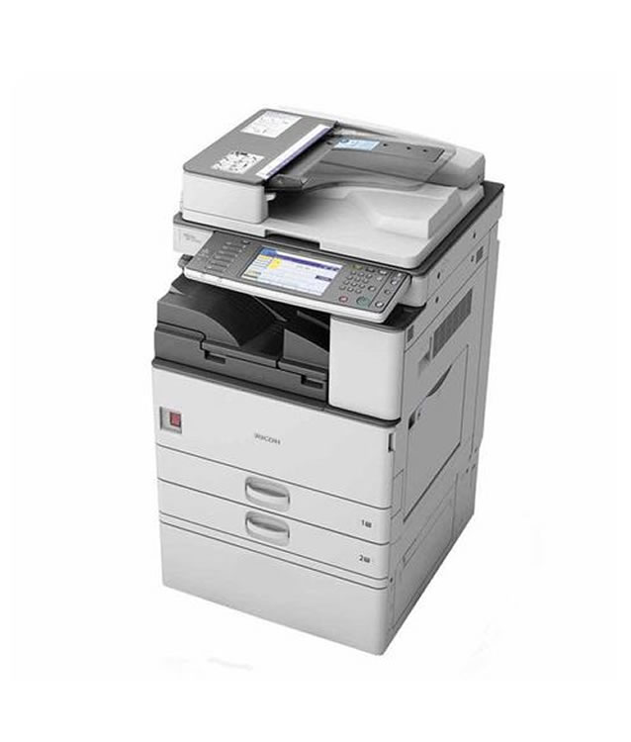

Ricoh aficio mp 2352

specs

- 23 papers per minute

- Functions: Print, Copy, Scan, Fax

- Up to 2 GB RAM/ 320 GB HDD

Price 75,00

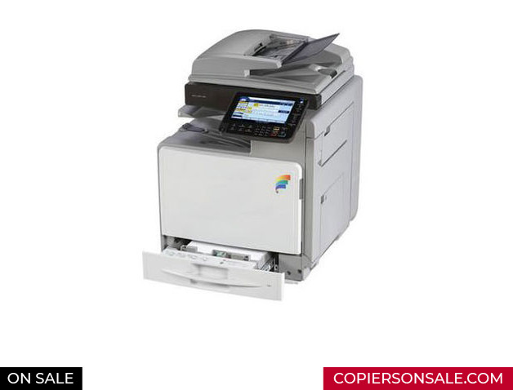

Ricoh Aficio Mpc 300

specs

Prints up to 32 ppm

print scan copy fax

67,000

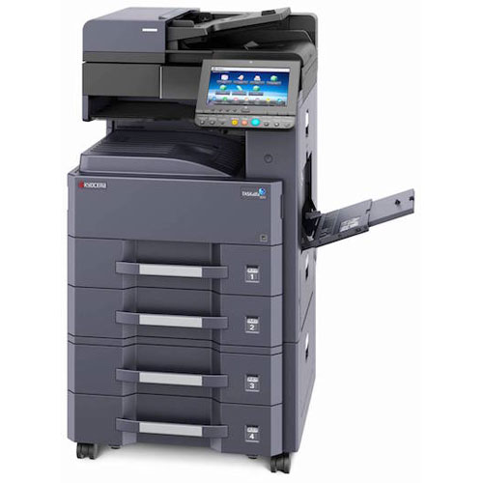

Kyocera Taskalfa 3011i

-up to 30 a4 pages per minute

-2 gb ram,320gb hdd

Price - 115,000



Kyocera 2560

-up to 25 a4 pages per minute

price 76,000